Ex.No. 15: AI-based Traffic Prediction for 5G Networks

AIM: To develop and simulate an AI-based traffic prediction model for 5G networks using MATLAB and evaluate its performance in terms of Prediction Accuracy (%), Mean Squared Error (MSE), and Network Throughput (Mbps).
Objective:
- To evaluate the Prediction Accuracy (%) of an AI-based model for forecasting network traffic in a 5G communication system.
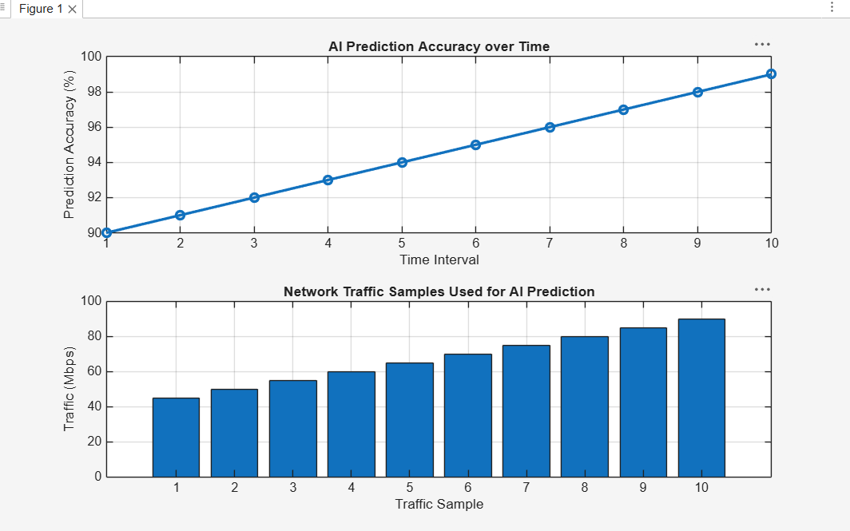
- To calculate the Mean Squared Error (MSE) between the predicted and actual network traffic values to assess prediction performance.
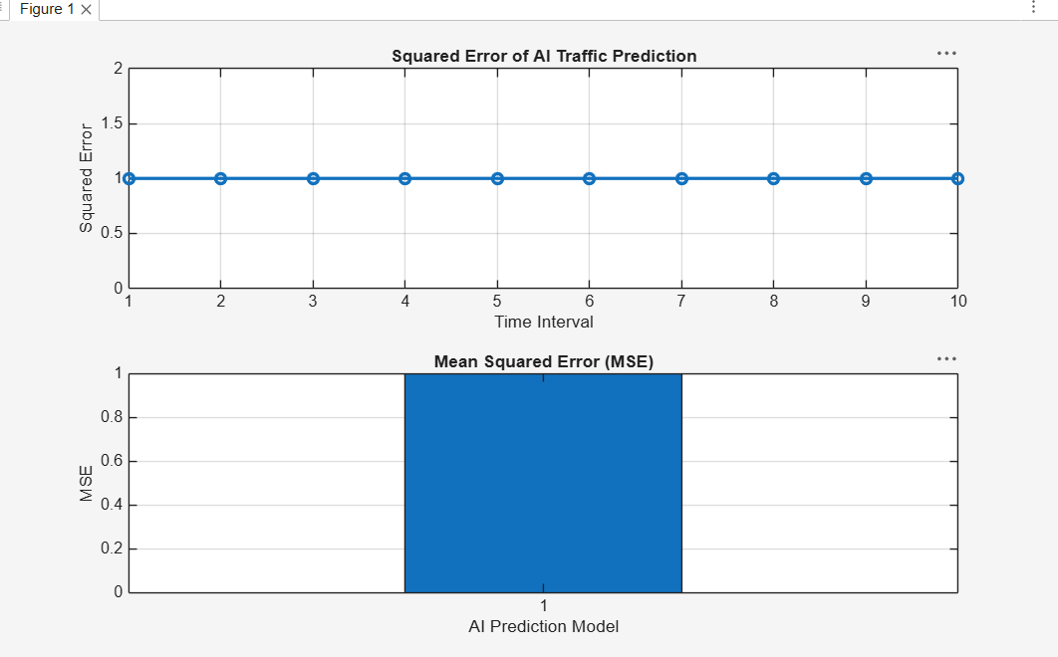
- To analyze the impact of AI-based traffic prediction on Network Throughput (Mbps) and evaluate the improvement in network resource utilization.
